Getting Started with HAARGIS
Getting Started
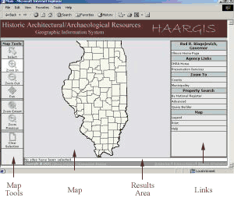
The main window of HAARGIS is divided into four areas: Map Tools, the Map, a Results Area, and Links.
Map Tools help the user navigate and perform specific tasks within the Map. The Results Area is where selected properties are listed and the user can find the details of those properties. The Links area has four sections: Agency Links to open the main IHPA Web site or the Preservation Services Division Web page; Zoom To links to help the user proceed quickly to needed information; Property Search to help the user find specific properties; and Map links that provide the map legend (and allow the user to turn layers on or off), and to print the map and search results.
Other windows are used for specific purposes: various search dialogs boxes appear when the user clicks on any of the links under the Property Search section in the Links area. A legend window that defines the symbols used in the map opens when the "Legend" link is clicked on. Reports on selected properties also are opened in a separate window.
Instructions for Some Common Searches
To search for all properties on the National Register of Historic Places (NRHP) in a specific county:
- Click on the "By National Register" link under Property Search in the Links area.
- In the "Select Search Region" window, click the radio button next to County, then click on the "Next" button.
- Scroll to find the county and click on it to select it--or begin typing the county name in the text box and automatically jump to the county. When the county name is highlighted, click the "Next" button.
- In the "National Register Search" window, click in the selection box next to one or more of the NRHP categories, and click the "Finish" button.
- A list of the properties that meet your specifications will appear in the Results Area of the screen. Depending on how many properties there are, you may need to page through them by using the "First," "Previous, "Next," and "Last" links.
- To identify where a property from the list of selected properties in the Results Area is on the map, click the "ID" link next to the property.
- To see details and photos about a property, click the "Report" link.
- To print the map and the results list, click on the "Print" link in the Links area of the page.
To search for a property by its address:
- Click on "Advanced" under Property Search in the Links area.
- In the "Select Search Region" window, click the radio button next to City, then click on the "Next" button.
- Choose the municipality (city) by scrolling through the list--or begin typing the name in the text box and automatically jump to the municipality. When it is highlighted, click the "Next" button.
- In the "Advanced Search" window, type the address in the text box below Property Address. Click the "Finish" button.
- Note: enter as much of the street address as you know. Do not enter the city or the zip code in this field. For directions, use N., S., E., or W. rather than North, South, East, and West. If you do not get any results from your search, try entering just the street name.
Map Tools of HAARGIS
Map Tools
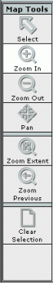
The Map Tools are designed to help you navigate in and around the map and to perform other specific tasks.

The Select tool allows the user to dynamically select sites. To use the Select tool, click on the tool and then click on a property on the map. Multiple properties can be selected by clicking and dragging a box around several properties.
The Zoom In and Zoom Out tools show more or less detail in a specified area. To use the Zoom In feature, click on this tool and then click on the map view. Wherever you click will be centered in the map window and made larger. To zoom in on a specific area, click and drag around that area and it will center and zoom in on that area. To use the Zoom Out tool, click on the tool and then click on the map. Wherever you click will be centered in the map window and made smaller.
To move the map display around in the map area, click on the Pan tool and then click and drag the map display.
By clicking on the Zoom Extent tool, the map display zooms out to its smallest extent--the view of the entire state.
The Zoom Previous tool returns the map display to the previous extent. (Note: there is only one previous extent stored in history.)

The Clear Selection tool can be used to deselect all selected properties whether they were selected by using the Select tool or through a query.
Map Layers of HAARGIS
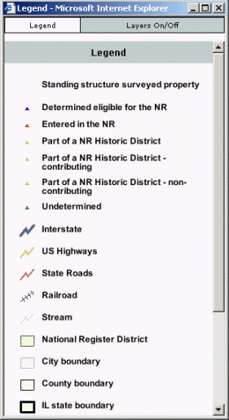
About the Layers
HAARGIS consists of spatial data sets having the same coordinates in space that are layered on top of each other to create the map image. Click on the Legend in the Links area for identification of map symbols. We have set specifications for each layer based on common usage--for example, at all extents, you can see the properties layer and the county boundaries; you must zoom in to the county level before you can see city boundaries; you must zoom into the city boundaries to see NRHP districts, and so forth. Even though these layers and the extent at which they are visible are set by default, users can turn layers on and off by clicking on the Layers On/Off tab on the Legend.
Turning Layers On/Off
To improve your map view, turn on only those layers that are important to you. With the Legend visible, click on the Layers On/Off tab. The layers that are presently visible in the map have a check mark next to them. Uncheck the box to turn off a layer, or check the box to turn a layer on. Click the "Refresh Map" button to display the changes.
Depending on the extent of the map view some layers will not be available to turn on. The extents at which each layer is available is given within the following section.

Description of the Layers
Each of these layers available in HAARGIS is described in detail below. We will be adding to some of the layers continuously, so please check back here often:
Standing Structure Surveyed Properties: These points have been plotted by Preservation Services staff for the following properties:
- Those properties on the National Register of Historic Places (NRHP). Each district has a point located in the center of the district as well as district boundaries identified by polygons in the National Register Districts layer.
- Those properties that have been determined eligible for the NRHP. This includes bridges on the Historic Bridge Survey and other properties designated eligible for the NRHP by the Keeper.
- Those properties that were included in the Illinois Historic Structures Survey.
- Those properties that were included in the Illinois Historic Landmarks Survey.
- Local landmarks in McHenry County, Galesburg, Normal, Jacksonville, Riverside, and Lake Forest.
- Certified Local Government (CLG) districts in McHenry County. Each district has a point located in the center of the district as well as district boundaries identified by polygons in the CLG Districts layer.
Note: NRHP properties were verified by maps available in the office; non-NRHP properties were geoaddressed (plotted automatically by their address) and have not been individually verified. We are presently adding properties and districts that have been determined local landmarks by CLGs, and will add properties from the Illinois Rural Survey, and a number of community surveys before we are done. This layer is turned on at all extents.
City boundaries: This layer was obtained from the Illinois Natural Resources Geospatial Data Clearinghouse. It is turned on by default and is visible at approximately a county-view extent.
County boundaries: This layer was obtained from the Illinois Natural Resources Geospatial Data Clearinghouse. It is turned on by default and is visible at all extents.
National Register districts: These polygons were plotted by staff at the Illinois State Museum and by Preservation Services staff from maps available in this office. These are approximate boundaries based primarily on city streets (specific verbal boundaries can be found in the NRHP application for the district). These are turned on by default and are visible at approximately a city-view extent.
Certified Local Government (CLG) Districts: These polygons were plotted by Preservation Services staff from maps available in this office. Presently only the CLG district in McHenry County is available in this layer. This layer is turned off by default, but can be turned on at the city-view extent.
Local Governments: These polygons were created by Survey staff based on the status of a city or county as a (CLG). This layer is turned off by default, but can be turned on at the county-view extent.
Interstate: These lines were created from the Topologically Integrated Geographic Encoding and Referencing (TIGER®) database of the United States Census Bureau in 2000. They are turned on by default at approximately the half-state view extent.
US Highways: These lines were created from the Topologically Integrated Geographic Encoding and Referencing (TIGER®) database of the United States Census Bureau in 2000. They are turned on by default at approximately the county-view extent.
State Roads: These lines were created from the Topologically Integrated Geographic Encoding and Referencing (TIGER®) database of the United States Census Bureau in 2000. They are turned on by default at approximately the county-view extent.
Other Roads: These lines were created from the Topologically Integrated Geographic Encoding and Referencing (TIGER®) database of the United States Census Bureau in 2000. They are turned on by default at approximately the city-view extent.
High Probability Archaeology: This layer was created by the Illinois State Museum. It is turned off by default but can be turned on at any extent.
Public Land Survey System (PLSS): This layer represents the Public Land Survey System (section, township, and range boundaries). It was received from the Illinois State Geological Survey. It is turned off by default, but can be turned on at approximately the city-view extent.
Streams: This layer was obtained from the Illinois Natural Resources Geospatial Data Clearinghouse. It is turned on by default at the city-view extent.
Railroads: This layer was obtained from the Illinois Natural Resources Geospatial Data Clearinghouse. It is turned on at the city-view extent.
Chicago Community Areas (CA): This layer of the boundaries of Chicago Community Areas was received from the Northeastern Illinois Planning Commission. It is turned off by default and can be turned on at any extent.
Federal Lands: This layer was obtained from the Illinois Natural Resources Geospatial Data Clearinghouse. It is turned off by default and can be turned on at any extent.
Floodplain: This layer was obtained from the Federal Emergency Management Agency. It is turned off by default, but it is available at the city-view extent.
House district boundaries:
Senate district boundaries:
Orthophotos: Orthophotos are aerial photographs that have had geographic coordinates added to them so they can be used with other feature layers and electronic mapping software. The orthophotos were produced by the United States Geographic Survey under the National Area Photography Program. These images can be turned on at approximately a one mile-extent. These images and the USGS Topographical Map images are mutually exclusive.
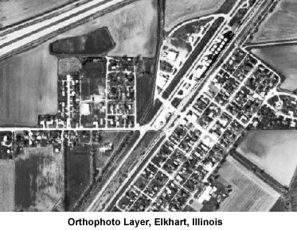
United States Geographical Survey (USGS) Topographical Maps: These images of commonly-used USGS maps show the shape and elevation of the terrain. They include drainage (lakes and rivers), forest cover, populated areas, transportation routes, and mark prominent natural and cultural features. These images can be turned on at approximately a one mile-extent. These images and the Orthophoto images are mutually exclusive.
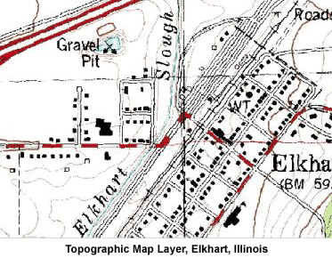

Searching
Zoom To
There are several options available to find properties in HAARGIS. If you want to view a specific area, you can zoom in to a view of a county or a municipality. | 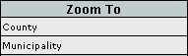
When you chose to zoom in to a county, a dialog box will open and you can select the county name from the list by using the scroll bar. Alternatively, you can jump to the county name by typing the first several letters in the text box. You can zoom into a municipality by using the same method. By zooming into an area using these two shortcuts, no properties are selected--you must use the "Select" tool or one of the other search methods to view property details in the Results Area.
Property Search
Use the options in the Property Search window to search for and to select properties based on specific criteria. | 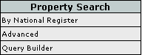
By National Register
To search by National Register (of Historic Places) status, you may first choose the location of the properties--either Statewide, or by County, or Municipality. Select one of the options within the radio button next to it and click the "Next" button. Then you may choose one or more of the formal NRHP standings:
- Listed in the National Register
- Part of a National Register Historic District
- Determined Eligible for the National Register
Click the "Finish" button to perform the search. View the results of the search in the Results Area.
Advanced
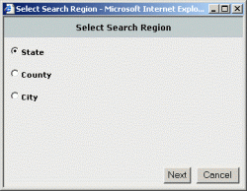
The Advanced search can be thought of as a query wizard because it makes searching for properties easy. In the Advanced search, you may only enter one search term per category, but you may enter search terms in several categories at once. In general, the more search terms you enter, the fewer results you will receive.
When you begin the Advanced search wizard, a dialog box opens to let you choose the location of the properties you wish to search for: State, County, or City. Click in the radio button next to your choice and click the "Next" button to continue. The following dialog box shows the first of the three tabbed areas: General, Individual Structure, and National Register Criteria.
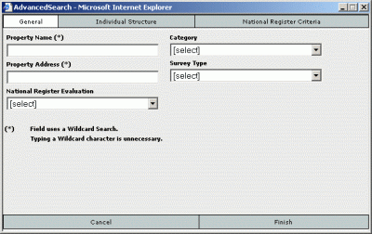
Wildcard Search Fields
The fields marked with an asterisk (*) are Wildcard Search fields and set up so that a user can type in a text string (like part of a name, or part of an address) and find the record without having to know the exact way it is entered in the database. For example, if you enter "Park Place" in the Property Name text box, your search will return results like,
- Lincoln Park, Park Place Cafe
- Linden Park Place--Belle Avenue Historic District
- Park Place Historic District
- Home Park Place.
Wildcard search fields are similar to keyword searches used in Google and other Web search engines, but the entire text string you enter is considered ONE keyword in this application. You will notice in the above example that no records containing only "Park" or only "Place" were returned. Only records in which the text string of "Park Place" appeared were returned.
General Tab
Under the General tab, you can search for a property by its name or address. Many of the properties, however, do not have specific names. Others have several names, some of which are used only on a local level. Unless the property is very well known, a name search may not find the specific property you seek. Searching by address under the General tab refers to the street address. If you are searching for a property in a specific city, the city is indicated on the first page of the wizard.
Also on the General tab, you can specify the NRHP status of the properties you are seeking. If you want to search for properties with specific NRHP criteria, click on the National Register Criteria tab. Note: you must make a selection in National Register Evaluation before you can use any options under the National Register Criteria tab.
Also on the General tab, you can specify the category (building, structure, object, site, or district) of the property you seek, or the survey in which it was inventoried.
Individual Structure Tab
Under the Individual Structure tab, you can search by specific details of individual structures that may appear on a property. A property may have one or more than one structure identified with it--a house, a barn, and a shed, for example. You may specify the architect, builder, or any of the materials that were used for the walls, roof, or foundation. These fields are wildcard search fields, so by entering "wright" in the architect field, you will find the buildings designed by Frank Lloyd Wright and other architects with the same last name. If you wish to enter both first and last names of an architect or builder, enter in the form of lastname, firstname.
You can also specify, by selecting from drop-down lists, the current function of the individual structure, and the historic function, and the architectural style. To find structures by when they were built, enter a year in the Begin Year and End Year text box. You must enter a value in both text boxes--to specify a building that was built in 1870, for example, enter 1870 in BOTH the Begin Year and End Year text boxes.
National Register Criteria Tab
If you want to search for a property on the NRHP by using criteria specific to that program, first select an option under National Register Evaluation on the General tab, then click on the National Register Criteria tab. (These are designations specific to the NRHP program--you may refer to http://www.cr.nps.gov/nr/ for more information.) You may select an owner type, a significance criteria, and a significance criteria consideration from drop-down lists. If you know the National Park Service certification number and/or certification date, you may search by those. You may also enter a significant area, and date range for that significant area (begin year and end year). You may also select a Multiple Property Listing from the drop-down list to see all of the properties listed by a theme (for example, Round Barns in Illinois, Carnegie Libraries, or Historic Fairgrounds in Illinois).
When you have selected all of the options from one or more of the categories, click on the "Finish" button to begin the search. You can see the results in the Results Area.
Query Builder
The Query Builder was designed to allow you to develop complex queries by manually creating search expressions based upon Structured Query Language (SQL). This type of searching may not be for everyone, but we have included the functionality for those who require complex querying. It allows you to search for multiple options within a category (the Advanced search function only allows you to enter one option per category). It also allows you to join search expressions based on the logical operators, AND, OR, and NOT (the Advanced search function links all expressions with the AND operator). Finally, it allows you to change the normal order of precedence by placing parentheses around groups of expressions. Those who are skilled in Boolean searching will find this method of searching very familiar.
The Query Builder screen helps you build queries by a simple series of steps. First, select the field name from the drop-down list of the first category in which you wish to search. When you select a field that has a limited number of options, like Category, you will see a text box appear with a drop-down list for you to choose an option.
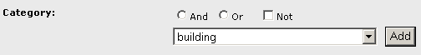
Select an option from the list and click on the "Add" button. The statement is then created in the "Where Clause" window:
(Unit.Category = 'building')
If this were the only condition you wanted to use for the search, you could click the "Finish" button to execute the search. However, if you want to add additional search expressions, select a second category from the Field Name list.
Not all fields have a drop-down list from which you can choose a search term. For example, you must enter your own search term into Property Name and Address. Fields that do not have drop-down lists are treated as wildcard searches.
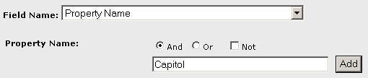
Notice that since this is the second expression, a logical operator is required--the AND operator is chosen by default, but you can select OR if necessary. (When you use the NOT operator, it should be preceded by an AND or an OR.) Click on the "Add" button to add this expression to the end of the existing Where Clause:
(Unit.Category = 'building') And (Property.SignificantName like '%Capitol%')
The wildcard characters and appropriate syntax are entered for you. You may at any time edit the search string that is created by clicking within the box and editing the expression as necessary. NOTE: There are no safeguards against entering illegal SQL syntax; edit these statements carefully.

Reports from HAARGIS
Reports
Following a search, or after you have selected a property or properties with the "Select" tool, you can generate a report on individual properties by clicking on the "report" link next to the property in the Results Area.
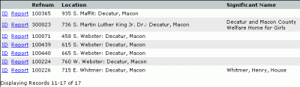
The report pulls together all of the known facts about that property and includes photographs that are available. It also contains links to additional documentation about the property. If the property is part of a historic district or part of a Multiple Property Listing (like Round Barns, or Carnegie Libraries), there are links to those reports as well. The following text discusses the type of information contained in the different report sections:
Name/Location
General property details appear in this section.
- The field, "vicinity," is listed as "yes" if the property is outside of city limits, but uses the city as its address.
- "Archaeology Comp." refers to whether or not the property has an archaeology component. If a property has not yet been assessed for archaeology, it will not have anything in this field.
- We have included PINs (propety index numbers) for those in municipalities that assign them and that have been identified with PINs on our survey forms.
- The Reference Number given is our unique identifier for properties in our database.
Property Listings
Within this section, the following programs are listed if they apply to the property:
- Listed in the National Register of Historic Places (NRHP)
- Part of a NRHP historic district (when known, the fact that the property is "contributing" or "non-contributing" is given as well)
- Determined eligible for the NRHP
- Within a Certified Local Government (and whether or not the CLG is approved for incentives under the Tax Act or Tax Credit program)
- Determined to be a local landmark by a CLG
- Part of a NRHP Multiple Property Listing (MPL). A MPL is used to nominate a group of properties for the NRHP based on a common theme. The MPL document contains information about resource types specific to a defined geographic region and describes a standard for the inclusion of these resource types in the NRHP. Properties listed under the MPL may be individual properties or historic districts.
National Register of Historic Places Information
Only properties that are listed on the NRHP will have details in this section. For an explanation of the details, you may visit the National Park Service site at http://www.cr.nps.gov/NR/.
Surveys of Property
Some properties have a link to "View Background Documentation." If background documentation is available, you need Adobe Acrobat ® Reader to view it.
Background documentation consists mainly of certain survey forms that were completed on the property. If the property is listed on the NRHP, the nomination form is included. If it was picked up in the Illinois Historic Landmarks Survey, that survey form will be included as well. Properties that were included in various community surveys will contain the full survey form used by those surveyors. The Illinois Historic Structures Survey cards and the Illinois Rural Survey cards (when entered) are not included in facsimile form because we included everything on the forms in our database.
For each survey that included the property, information about the survey is included in this section: Survey Type (name of the survey), Date of Survey, Survey Prepared By (surveyor name), and if included in the survey, the surveyors opinion of significance, condition, and integrity.
Property Details
By our definition, a property can have one or more buildings, objects, sites or structures. In this section, the details of each individual unit is given. (The order in which units are listed is not significant.)
Photographs
A sampling of our file photographs is presented in this section of the report. If known, the photo date is given, along with the location of the original photograph in our files. The PhotoID is the unique number that identifies each photograph.
If you wish to enlarge the photograph, you may right-click on it and save the photo on your computer and view it using an image viewer or editor.
Comments to HAARGIS
Please send us your comments and/or corrections!
While every effort has been taken to ensure the accuracy of the data in HAARGIS, some factors are beyond our control. Properties may have been demolished or moved since surveys were taken, and addresses may have been changed. In addition, incorrect addresses may have been recorded on survey forms. Also, the information contained in HAARGIS may be outdated in some instances. This Web site functions as a research tool, not an up-to-the-minute inventory about every historic and/or architecturally significant property in the state. This tool allows researchers to investigate and review potentially significant properties according to the best data that is available in Illinois' historic preservation office.
Accordingly, we would appreciate receiving updated information from you regarding the properties contained in HAARGIS. Please send your comments to us at info@ihpa.state.il.us.

